First Paper: Microfluidic device for continuous…
- Nothing much found within the paper itself- provided optical images and Scanning Electron Microscope (SEM) images
- From reference/link 8: J. Wu, X. Z. Wu, T. Huang, and J. Pawliszyn, Analysis of Proteins by CE, CIEF, and Microfluidic Devices with Whole-Column-Imaging Detection, M. A. Strege, A. L. Lagu, eds. (Humana Press, 2004).
  - I was able to find reference/link 10 of Wu: Universal Detection for Capillary Isoelectric Focusing without Mobilization Using a Concentration Gradient Imaging System
Second Paper: Multidimensional Laser Confocal…
- No mention of imaging software, seems to just be part of the microscope system set-up
Links from Matlab Support:
“Here are the bunch of links which talks about how to do some image processing with cells as well as some work done by other people in this area using Image Processing Toolbox:”
https://www.mathworks.com/help/images/detecting-a-cell-using-image-segmentation.html
https://www.mathworks.com/company/newsletters/articles/using-image-processing-and-statistical-analysis-to-quantify-cell-scattering-for-cancer-drug-research.html
https://www.mathworks.com/solutions/biological-sciences/microscopy-biomedical-imaging.html
- https://www.mathworks.com/matlabcentral/fileexchange/74200-rfove-cell-segmentation
https://blogs.mathworks.com/steve/2006/06/02/cell-segmentation/ -leads to SEG-SELF, etc.
Links found from Google searches:
https://www.mathworks.com/products/image.html#iman
https://www.mathworks.com/matlabcentral/fileexchange/67313-cell-segmentation-seg-self-method -seg self method (automatically identifies and splits touching cells and such) --https://www.mathworks.com/matlabcentral/fileexchange/74200-rfove-cell-segmentation
https://blog.pedro.si/2014/04/basic-cell-segmentation-in-matlab.html -multiple filter applied method
https://www.mathworks.com/company/newsletters/articles/developing-in-vivo-functional-imaging-technology-with-micron-scale-resolution-using-optical-coherence-tomography.html -method from Standard using large gold nanorods
https://www.pnas.org/content/113/18/4947
- 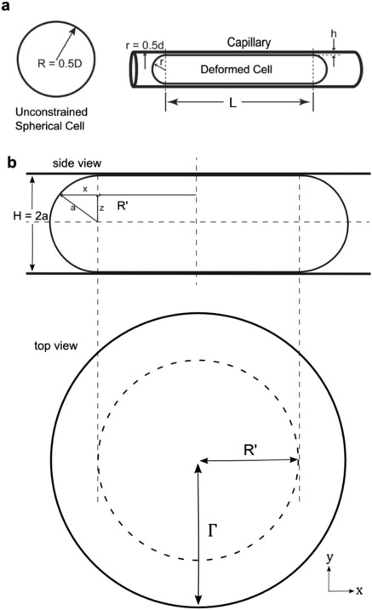 -calculations from SEG-SELF, might adjust for our purposes, could be standard

Start of MATLAB Coding_10/16/2020
10/16 to 10/23
Blue image- source image.jpg
Gray image- finalfilteredim115.tif
Utilizing the Basic Cell Segmentation method (https://blog.pedro.si/2014/04/basic-cell-segmentation-in-matlab.html)
-utilizing blue image: cannot apply grayscale filtering and such or else the image will filter out the cells(blue circles), applying other filtering: minimal differences were noted–decided to move to the gray image for this route of image processing
Utilizing gray image: while not extremely noticeable at first, the filters helped accentuate the cell outlines, which is believed to make them easier to account for with the next parts of coding
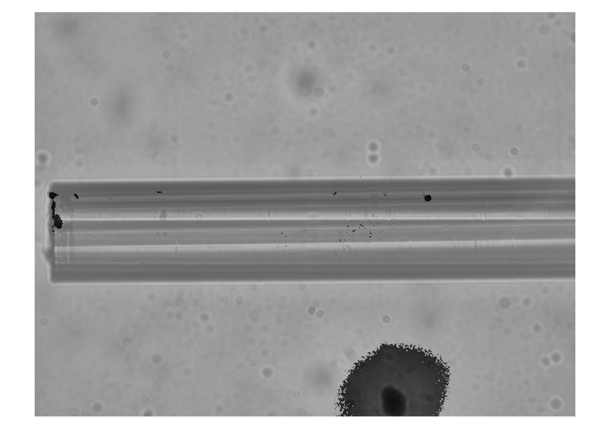
Filtering

